*Village of*



Smoke Signals

*November 2021 EDITION*



**The Ozarks offer some of America's most beautiful scenery, particularly in autumn when fall foliage is at its peak. Maples, oaks, ashes and hickories in the area generally reach vibrant colors around mid-October, making it the perfect time for leaf peeping in Indian Point.**

***If You are in need of any of the following information***

***Stop by the Village office for assistance:***

Property Setbacks

Tree Removal & Tree Trimming

Zoning of Property

Stone County Septic Regulations

Land Clearing

Building and Construction

Business and Occupation

Land Use

Emergency Management

Special Events

Garage Sales

Parking

***Indian Point Fall Clean UP***

**November 4 & 5, 2021**

**“We Haul” trash service will be picking up everything that two men can carry. Please put trash by curb the night before. If you have any questions please call the Village office at**

**338-5599.**

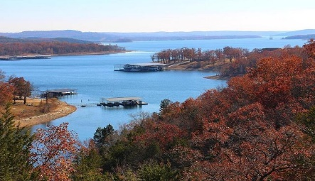

***Public Works Update***

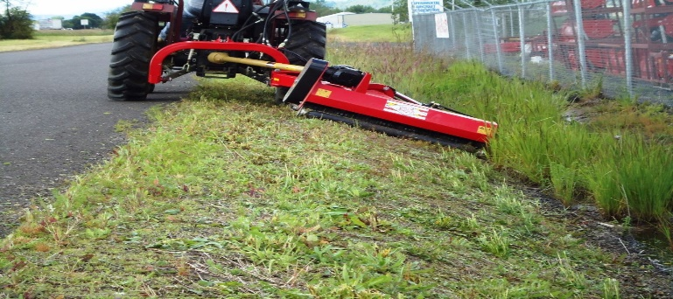

**Flags Hung**

**Trees Cleared from Ditches**

**Fall Pavement Bids on Roads**

**Helicopter Landing Zone Improvements**

**Mowing and Weed Eating**

**Guard Rail Repairs**

**Road Signs**

**Culvert Work**

Indian Point Women’s Club was organizxed January 25, 1973. The Club supports philanthropic endeavors to raise funds for various Stone County, MO charities.

***Coming Soon:***

Indian Point Women’s Club Lending Library

**Located: Village Office**

Gathering a network of neighbors and friends who are invested in the well-being of your Little Library is key to long-term success. Start by spreading the word. Remember, you don’t need to wait until after your Library is installed to start promoting it.

Spread the Word







**CONTACT US!**

**Indian Point Board of Trustees**

**Sue Wright, Board Chairman Denise Petersen, Vice Chairman**

**Lori Minshall, Trustee Helen Slagle, Secretary/Treasurer Chris Houghton, Trustee**

**VILLAGE OF**

**INDIAN POINT**

**957 Indian Point Road**

**Branson, MO 65616**

**Suzy Anglim, Village Clerk Ron Berger, Village Administrator**

**Email:** [**village@indianpoint-mo.gov**](mailto:village@indianpoint-mo.gov) **Email:** [**admin@indianpoint-mo.gov**](mailto:admin@indianpoint-mo.gov)

**Dale Petersen, Public Works Allen Hamlin, Chief of Police**

**Email:** [**pworks@indianpoint-mo.gov**](mailto:pworks@indianpoint-mo.gov) **Email:** [**chief@indianpoint-mo.gov**](mailto:chief@indianpoint-mo.gov)

**Phone: 417-338-5599**

**Fax:** **417-338-5279**

**Village Hours**

**Monday-Thursday**

**9 AM to 4 PM**

**Closed for Lunch 12 – 1PM**

**To contact Indian Point Police:**

**911**

**Non-Emergencies**

**417-386-4203**

**or**

**417-399-9117**