Welcome 2024!  The Village of Indian Point Newsletter |  | January 2024
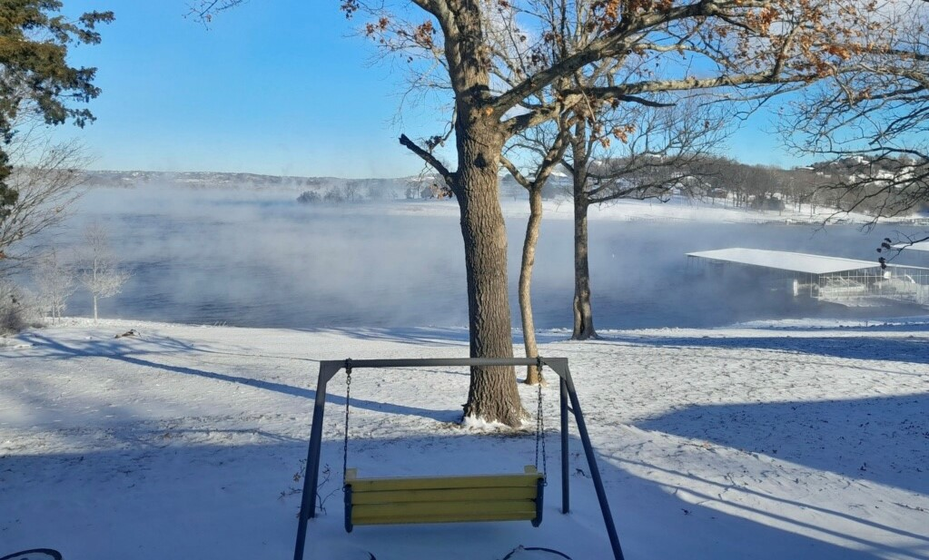
What’s going on at the Village Hall?  Financials: Show me the Money!  Village:  December Sales Tax Revenues were short of projections by 33.7% and 10.6% below last year.  FY Sales Tax Revenues of $991,904 are short of forecast by $38,047 (3.8%).  December expenses are under budget by $37.7K (42.2%).  FY expenses ($1,001,038) under forecast at $23K, or approximately 2.3%.  2023 ends with a surplus of $79,049.  Sewer:  December Sewer Revenues ($8.7K) are under forecast.  FY Sewer Revenues ($183,798) are ahead of the original budget and forecast and finish the year over the September reforecast by $19.3K (11.7%).  December Expenses ($10.8K) are under forecast by $6.3K (36.8%).  FY Sewer Expenses ($131.2K) are also under budget by $5.7K (4.2%).  FY Sewer Operation resulted in a surplus of $53.3K. |  | Let’s find out!
Implement a 2024 Budget
Budget was approved and was flat with last year’s expenses to ensure a surplus in 2024.
Financial Oversight
All Departments will operate on a “is this in the budget” approach and/or is this a “need” for the Village.
We are Ready!
Your Part Time Controller will be assisting the Village for financial oversight services!

Accounting Administration  Sewer: Sewer Revenues ended for 2023 at $184,521.34.  A past-due amount of $1074.00 was collected.  MODOR: Shannon is currently working on a project to gather information on properties within Indian Point. It consists of; narrowing down the current owner of properties in Indian Point, what management company represents the property if it is nightly rental, where the sales tax is paid, and tax Id numbers on file to assist in monthly Missouri Department of Revenue audits. Shannon is sending out a letter to gather information and then complete further research on the back end. This project has been successful so far in the gathering of information from those who are not yet listed with The Village of Indian Point. Once completed, this will help with the Village’s data collection on the number of overall units within the Village as well as assuring proper tax collection.  Training: Shannon is working on the completion of her second Accounting Certificate and should be completed in February.  Meetings: Shannon and Chief Lucas attended the end of year Chamber Luncheon on December 7th.  Shannon and Beth volunteered and assisted in the Stone County Toy event on December 11th.  The Gingerbread House contest was held on December 8th and was a success! This was also featured in the Branson Globe!  Wedding Bells! You may notice in the upcoming months, a change in Shannon’s last name! Shannon got married to Chris Campbell on New Year’s Eve! Don’t be alarmed when you see start seeing the change from McQuality to Campbell! |  |  | The Village Clerk  Golf Carts: One Golf Cart permit was issued for December. We had a total of 44 permits issues for 2023. Grab yours now for 2024!  Business Licenses: Four Business Licenses were issued in December and a total of 149 for 2023. Beth has worked hard to mail out the new Business Licenses for renewal! Beth has also redesigned the Business Licenses application to be more efficient and easier for applicants. She has also worked to revamp the look of the Village’s Business License to look more professional. The DEADLINE for Business Licenses new and renewal is March 31st!  Sunshine Requests: There was a total of 32 Sunshine Requests for 2023.  Other News: Need a lesson in filing, ask Beth! She has been cleaning out the old and getting ready for 2024. She is also reorganizing all the Ordinance Binders for consistency.  Beth has recruited 2 new people for the Lodging Committee! Welcome Allen Prince and Susan Halfacre!
Join our committees! | P&Z – Planning and Zoning: Meet the 1st Wed of every Month.  Lodging Committee– 3rd Wed of every Month.  If you are interested in serving your community on any of our committees, please reach out to the office!

Planning and Zoning: Welcome new P&Z members Tony Colon and Jane Murphy!
A Public Hearing was held on January 15th over the proposed Fence Ordinance.
Department of Commerce/U.S. Census: Every year we must report a “ summary level data on the number and approximate valuation of residential housing units authorized by building or zoning permits issued by your office during the calendar year of 2023”. Nathan has started working on this and has everything collected except for valuations. This is the same report Nathan worked on last year with the Department of Commerce to get the Village caught up for the years 2018-2022.
Boundary & Annexation Survey: This is a review of Municipal boundaries that is used for: Data collection, Tabulation, Dissemination for the Decennial Census, American Community Survey, Population Estimates Program, and other censuses and surveys. This Boundary information is used by the Census Bureau and the Federal Government allocates more than $2.8 trillion in federal funds annually for health, welfare, infrastructure, education, and other federal programs and services. Correct boundaries ensure governments receive funds appropriately and have the best data available for their decision-making processes. Nathan has signed up to take the training course given by the Census Department on how to accurately report and input this data.
Village Handbook Review: Nathan has reviewed the New Village Handbook created by HR Advantage along with Shannon and input was sent to HR Advantage for review. Further discussion on the New Village Handbook will be continued in the February meetings.
Budget: NATHAN: “SHOUTOUT” to all staff who gave me good input at our budget meetings throughout the budget process. Especially Barbara who has worked a lot of long days getting Your Part Time Controller caught up with our process as well as Shannon for working with me A LOT of hours to get our numbers & notations correct.
Trail Project: Dawne (City Manager of Kimberling City) reached out to Nathan about doing a joint trails project between Kimberling City, Branson West, and Reeds Spring. They plan to discuss it further with the rest of the City Administrators to see if it’s viable.

Village Coordinator
Do you have Planning and Zoning questions?
Visit our website!

Hard at Work
Winter Ready: The guys were hard at work during the cold weather and snow making sure that the roads stayed cleared for the residents in our community! We appreciate everyone’s patience as they experienced a few mechanical issues with our plow truck that they had to fix in house late at night. A HUGE THANK YOU!
Newbie: The Public Works Department will soon be receiving a well overdue new work truck that will be used for road maintenance and snow plowing! They are very much looking forward to this!
Training: Vouchers for Wastewater Training were received from The Department of Natural Resources.
If you need anything, Daron and Lance are the duo to get it done!
Indian Point Police Department  On Patrol: The Indian Point Police Department had 26 plus calls for December. The IPPD logged 809 miles of patrols on the point and immediate area. If you would like more patrols on your street, please let the Chief or any officers know, and they will accommodate. The IPPD are also doing Vacation Checks on specific residence when requested.  IPPD OUTREACH: The Chief attended the Missouri Investigators meeting in Springfield on December 12th. Mibers Submissions were made for January through November. Thank you, Sandy Steel, for assisting in this endeavor. This is a Big Deal and a huge accomplishment for the IPPD!  2024 ARPA Grant application submitted for Police Department Capital improvements. IPPD attended the Stone County Reserve training session on January 8th. Chief Lucas also attended the Outlaws meeting on January 10th and the Regional Police Chief’s monthly meeting on January 11th.  IPPD Checks and Contacts: Foxfire Resort, Bavarian, Alpine Lodge, Clear Lake Investments, The Outpost, Artilla Cove Resort, White Wing Resort, Calm Waters Resort, Happy Valley Lodge, Antlers Resort, The Lodges, The Cottage Resort and Market.  No Crime Zone: The IPPD received information from Ozark Police Department that a person who was wanted by several counties for pending warrants and charges had previously been observed driving around Indian Point. The Chief confirmed the vehicle was in fact on a property located on the point and advised a plan with the assistance of 4 Stone County officers to apprehend the subject. Contact was made with the subject and the subject was detained. The IPPD also seized narcotics and contraband during the arrest. The result of this arrest will clear warrants in 4 different counties.  Want a 2024 IPPD Calendar? Stop and say HI to the Chief and grab one for free! |  |  | Community Member of the Month!  January 2024  Congratulations to the Women’s Club!  The Indian Point Women’s Club do so much for our community and the Village Hall. The club spends time raising funds for local charities like the Southern Stone County Food Bank who they recently donated over $645 to. They are very supportive of local businesses within The Village of Indian Point and always willing to help their neighbors. Every year the Women’s Club decorates the Village Hall inside and out, bringing with them the Holiday Spirit. The Women’s Club also puts together a tree lighting event every year that brings our community together! The Indian Point Woman’s Club is a great asset to the Community and the Village Hall. We THANK YOU!  Happy 50th Anniversary!  Missing is Denise Petersen as she is taking the picture.
Want to be a part of the Indian Point Women’s Club? | The Indian Point Women’s Club is open to women who reside in  The Village of Indian Point, either full time or part time.  For more information please email:  r_s_mcspadden2x@hotmail.com

Nature At Night on The Lost Canyon Cave & Nature Trail

TOP OF THE ROCK
Experience the Ozarks after dark at Top of the Rock and join us for a 2.5-mile journey through Nature at Night! Enjoy this unique light tour experience with awe-inspiring displays resembling historic Native American scenes along with traditional holiday vignettes. Sip on hot beverages and be surrounded by twinkling lights and a festive spirit while connecting to the great outdoors. Make this season one to remember and start a new family tradition at Nature at Night on the Lost Canyon Cave & Nature Trail!
Admission to Top of the Rock for Nature at Night requires a $15 Parking Fee (credit card only). Paid upon entry.
- Adult price range: $39-$44
- Child prices start at: $19.
- Open November 2023 – January 2024
- 5pm-9pm
For your safety weather may impact your tour, ice on the trail develops frequently during lower temperatures and may delay or cancel tours. Please check our website 2 hours prior to your tour time for updates. Cancelled tours will automatically be refunded to your credit card, please allow 5-7 business days to see that in your statement.

Minute to Win-it$5.00.
1 Hour
Do you have what it takes to win it in a minute? Join us at Fun Mountain for an hour of silly and challenging games. Winning teams will be awarded prizes and random trivia questions will be asked throughout the activity for bonus prizes.
- Dates: Fridays January 9- February 23 Mondays in March
- Times: 5PM
- Location: Table Rock Event Room at Fun Mountain
- $5 per person
- Open to the public, reservations are required.

Not so Newly Wed Game Night

BIG CEDAR LODGE
Whether you’ve been married for one year or 30 years, it’s time to test how well you know your partner. Battle with other couples as you enjoy a series of question rounds to determine just how well you know (or don’t know) your partner. Each couple will receive a giant pretzel to share and a glass of wine or beer. Prizes will be awarded to the winning and losing couples.
- Dates: Saturdays in February
- Time: 5PM – 7PM
- Location: Table Rock Event Room, located at Big Cedar Fun Mountain
- Cost: $50 per couple
- Participants must be 21 or older.
- Open to the public

SCHEDULED MEETINGS
Committee | Meeting Time
Trustees' Workshop | The Monday proceeding the Trustee Meeting (unless otherwise posted)  5:00 P.M.

Planning & Zoning | 1st Wednesday of each month (unless otherwise posted)  6:00 P.M.
Board of Trustees | 2nd Wednesday of each month (unless otherwise posted) 6:00PM
All meetings are held at the Village Municipal Building, 957 Indian Point Rd, unless otherwise posted.

Additional Meetings:
- Lodging Committee – Every 3rd Wednesday of the month
Added this Month:
- No additional meetings were added to the calendar for January at this time.
Please submit all Community Members of the Month Nominations no later than the 1st Friday of every month. If you need a form to submit a nomination, please email or call the office.

